Difference between Web API 2 nad .Net Core API

Web API 2 | .Net Core API
1.Web Api does not have a view engine like the MVC Controller (Razor View Engine) and was designed to be used to build REST APIs to serve Json data. | 1.The new MVC 6 that comes with ASP.NET Core has the best of both MVC and Web API worlds from ASP.NET.Now you can serve a View or a Json response to a client from the same Api Controller.
 | 2 Execution stack is faster.

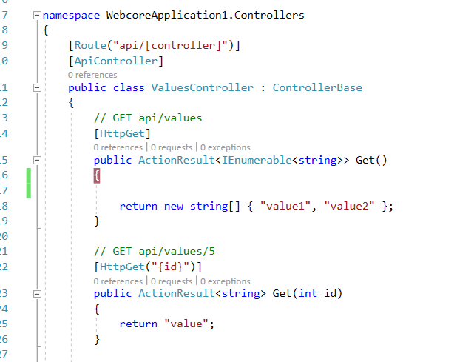

As we can see that the action method has the return type of action result which can return both Json data as well as a view.

When to choose .Net Core over Web API 2

There are cross-platform needs.
Microservices are being used
When Docker containers are being used.
If you are running multiple .NET versions side-by-side
If you want command line interface (CLI) control.

